SAVE THE DATE
South Bay Consortium for Adult Education Presents:
The 2018 Adults with Disabilities Summit
This year’s summit will be focused on employment and vocational training needs for Adults with Disabilities.
Fri, November 16, 2018
9 AM – 4 PM
Baltic Room
West Valley College
1400 Fruitvale Avenue,
Saratoga, CA 95070

Join the invite list! Email: Johanna.hembry@westvalley.edu

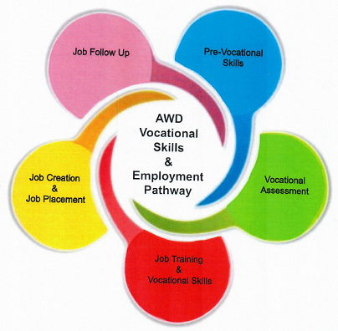

SAVE THE DATE
South Bay Consortium for Adult Education Presents:
The 2018 Adults with Disabilities Summit
This year’s summit will be focused on employment and vocational training needs for Adults with Disabilities.
Fri, November 16, 2018
9 AM – 4 PM
Baltic Room
West Valley College
1400 Fruitvale Avenue,
Saratoga, CA 95070
Join the invite list! Email: Johanna.hembry@westvalley.edu

